Spot the Difference Task

Rational

This spot the difference task is designed for beginning Alutiiq language learners. In this task, students work in groups of three: two students are given nearly identical pictures containing a set number of differences. The students, without looking at each other’s picture, must try to find as many of these differences as they can. The third student listens and takes notes on what he/she hears. This task includes pictures found at www.nickjr.com.

This activity supports language learning through these means: meeting the criteria for task based language teaching and requiring the learners to produce output.

Task Based Language Teaching
Ellis (2009) presents the criteria an activity must meet to be considered a “task”: 1. The primary focus should be on ‘meaning,’ 2. There should be some kind of ‘gap,’ 3. Learners should have to rely on their own resources to complete the task, 4. There is a clearly defined outcome aside from the use of language (p. 223).

The spot the difference task meets the criteria to be considered a “task.” This is a meaning-focused activity as each learner must communicate what he or she sees in their picture and determine what is different about what their partner’s picture. There is a gap in the students’ information as they are looking at different pictures. The outcome for this activity is for each pair to find as many differences in the pictures as they can. The learners will rely on their own language knowledge to complete this activity.

Output Hypothesis
Swain (2000) postulates that it is dialogue that constructs linguistic knowledge (p.97). She goes on to describe that the language use is mediating the learning of the L2. Swain (1995) explains that, “output pushes learners to process language more deeply- with more mental effort- than does input,” (2000, p. 99). When producing output, learners can ‘stretch’ their interlanguage to accomplish their communicative goal. When producing output, students are able to notice the difference between what they are able to say and what they want to communicate, they are able to develop and test hypotheses about how the target language works, and they can reflect on the language they have learned.

This spot the difference task requires learners to comprehend input and produce output in order to communicate what is in the picture they are looking at and determine what is different between the pictures. Students will have the opportunity to notice the gap between what they want to communicate and what they are able to say. Students will be actively testing their hypotheses about how the language works.

Description

1) Pre-Task
The teacher will project a similar scene as to those in the task. Project just one picture to begin with.

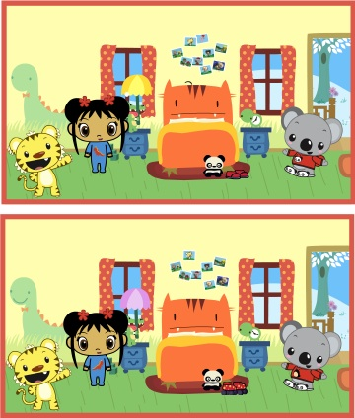

The teacher will ask the students to describe the picture.
The teacher can probe by asking questions such as:
- Caqiq una? (Pointing to different items in the picture)
- Kinkut ukut? (Pointing to different characters in the picture)
- Naama ukut?
- Caquciq kRaaskaat una? (pointing to different items in the picture)
- Caugcineq patRiitat ukut?

The teacher can call the students’ attention to what he/she wants them to focus on. For example, pointing to the lamp and asking, “Caqiq una? Caquciq kRaaskaat una?” etc.

Then the teacher projects both pictures and asks the students to find the differences between the pictures.

2) Task Cycle
Students work in groups of three.

A divider, such as two folders, is placed between two students so they cannot see each other’s papers.

In each pair, one student is given picture A, while the other student is given picture B. The third student takes out a piece of paper and a pencil.

Tell the students that there are eight differences between their pictures. They will need to try to find as many differences as they can between the photos. The third student will take notes on what they hear during the task.

The goal of the activity is for each member of the pair to find the differences WITHOUT looking at their partner’s worksheet.

When students have found as many differences as they can, they can share their pictures and compare their information.
Here we have three versions of picture pairs. You can give each group a different picture, or give each group the same set of pictures.

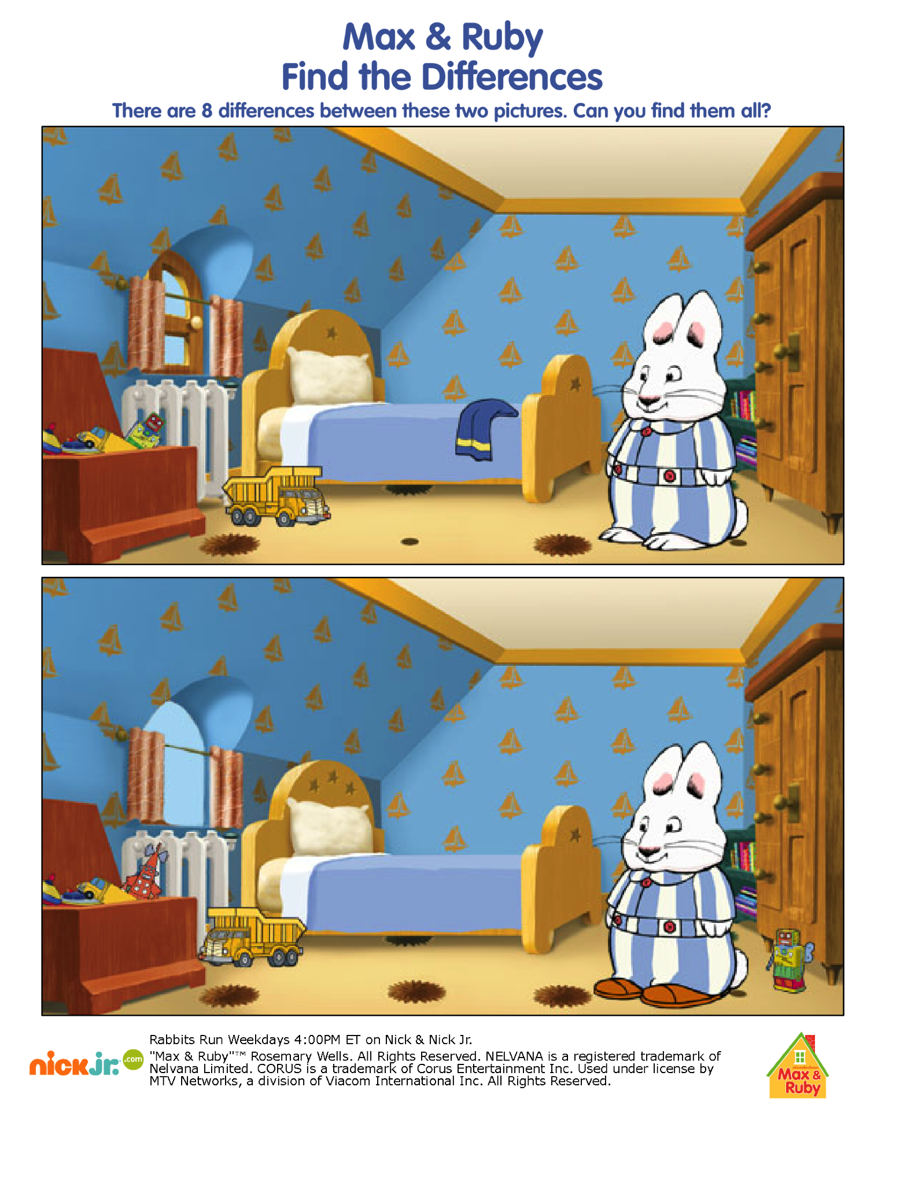

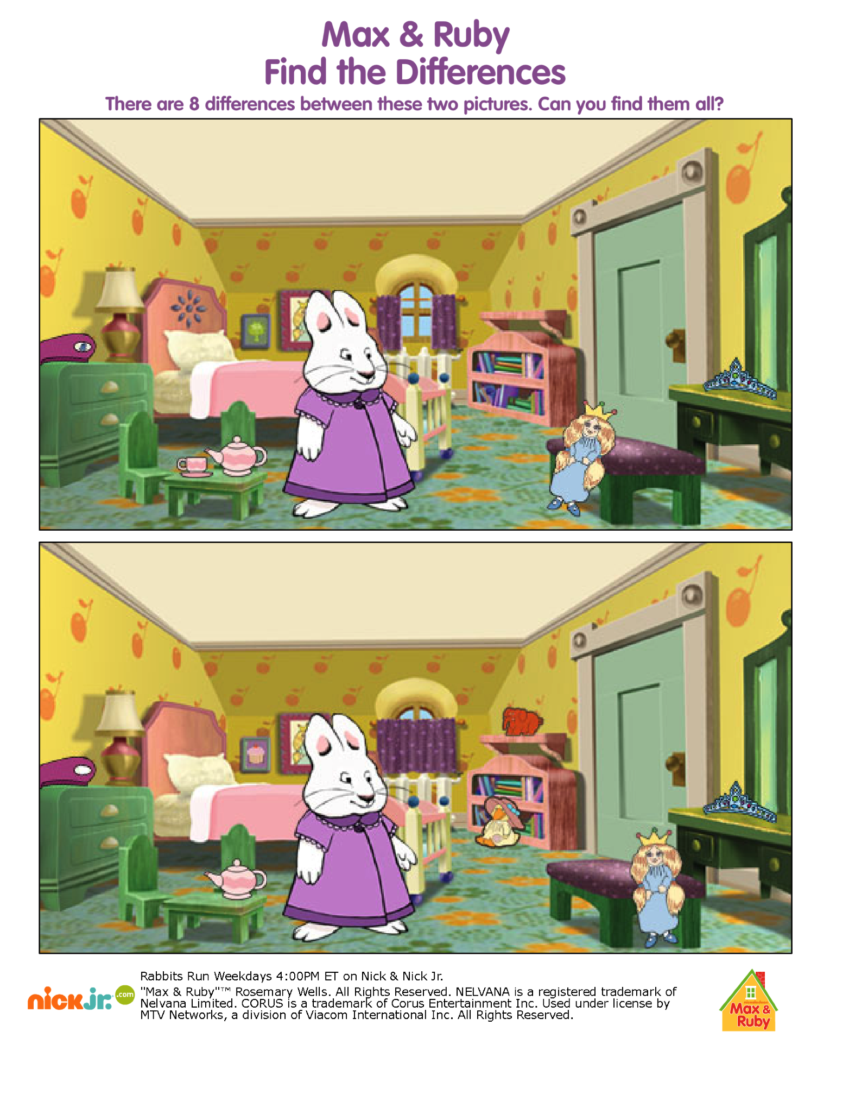

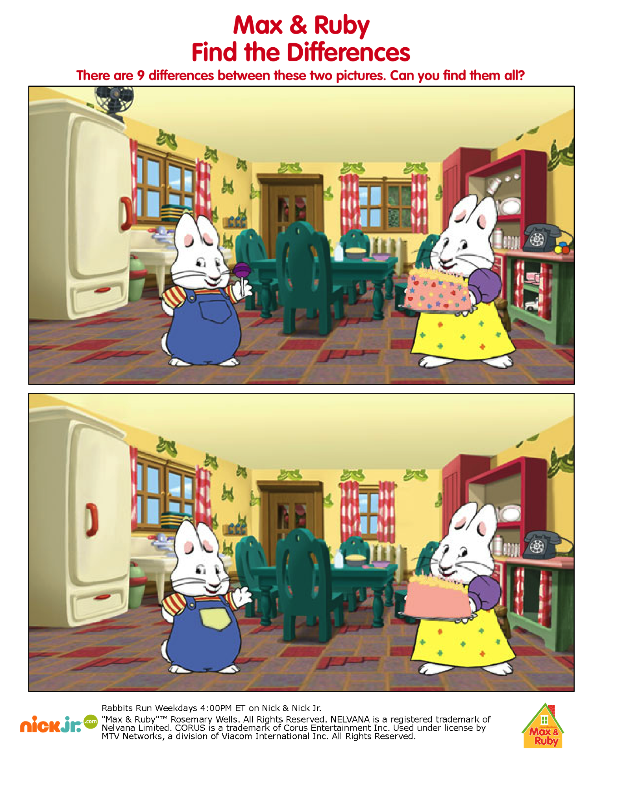

Post Task
The teacher will project each set of pictures.
Groups will be invited to share differences they found in their pictures.
The note taker will be invited to share what language they heard during the task.

The teacher will ask students if there was something that they were wanting to say, but didn’t know how to say it? Ask them to share.

The teacher will give the students the opportunity to ask any language questions they have.

Reflection
I have not used this activity with my class. I have designed it for use with my secondary beginning Alutiiq class. We have just begun learning about locations and items within the home. We have just completed a unit on descriptive language using numbers, colors, etc. to describe things. I feel that most of my students would be able to find some of the differences involving colors and numbers. They may struggle with asking the questions of each other, such as “Caugcineq patRitat?” They have not practiced asking others these questions, but have responded to the questions. Some of my less confident students will have trouble testing their hypotheses by putting themselves out there and making errors.

References

Ellis, R. (2009). Task-based language teaching: Sorting out the misunderstandings. International Journal of Applied Linguistics, 19, 221-246.

Swain, M. (2000). The output hypothesis and beyond: Mediating acquisition through collaborative dialogue. In J. P. Lantolf (Ed.), Sociocultural theory and second language learning (pp. 97-114). Oxford: Oxford University Press.

