Optical Illusion Task

Rational

This opinion gap task asks students to look at images containing optical illusions. In pairs, students will look at an image and describe what they see to their partner. This activity is designed for beginning Alutiiq learners. It can be easily adapted to be used with intermediate learners. This activity uses images found at illusions.org and brainbashers.com/opticalillusions.com.

This activity supports language learning through these means: meeting the criteria for task based language teaching and metacognition.

Task Based Language Teaching
Ellis (2009) presents the criteria an activity must meet to be considered a “task”: 1. The primary focus should be on ‘meaning,’ 2. There should be some kind of ‘gap,’ 3. Learners should have to rely on their own resources to complete the task, 4. There is a clearly defined outcome aside from the use of language (p. 223). The optical illusion opinion gap activity meets the criteria to be considered a “task.” Each learner brings their perspective to the image they are given, and they must communicate their perspective to their partner, meeting the first two precepts for TBLT (focus on meaning and a gap). The outcome for this activity is for each student to try to convince their partner to see what they see in the optical illusion; the learners should be able to use their knowledge of the language and resources to complete the task.

Metacognition
Metacognition involves thinking about one’s thinking. Anderson (2008) states that, “Metacognition results in critical but healthy reflection and evaluation of thinking that may result in making specific changes in how learning is managed, and in the strategies chosen for this purpose,” (99). He believes that learners who reflect upon their learning are better able to make decisions about how to improve their learning. The author introduces five components to metacognition: 1. Preparing and planning for learning, 2. Selecting and using strategies, 3. Monitoring learning, 4. Orchestrating strategies, and 5. Evaluating learning.

During the pre and post-task activities, students will be given a chance to think and talk about their thinking and learning. The teacher, using a KWL chart, will ask students to reflect on the language they know and need to know to complete the task. The students will monitor their learning and propose strategies that will help them improve their learning.

Description

1) Pre-Task
The teacher will model this activity for the students.
The teacher will work with another person (either another learner, Elder, or a pre-coached student) to model the language possibilities for this activity.

The teacher and her partner will be looking at an optical illusion image projected on the board.
Example:
The teacher would say things like:
- “Tangraqa una arnam giinaq.”- I see a woman’s face
- “Gwani iingalak.” (pointing to her eyes)- Here are her eyes
- “Gwani paciguak.” (pointing to her nose)- Here is her nose
- “Gwani qaneq.” (pointing to her mouth)- Here is the mouth
The partner would say things like:
- “Tangraqa una nukallpiaq.”- I see a man.
- “Gwani nasqua.” (pointing to the head)- Here is his head.
- “Guani paciguak.” (pointing to his nose)- Here is his nose.
- “Guani una cauyuteq.” (pointing to the saxophone)- Here is a musical instrument.

2) Task Cycle

Students work in pairs.

Each pair is given one image to look at. The students in the pair are numbered one and two.

Instruct the students to look at the photo and think about what they see in the image. Give the students a few minutes just to look and decide what they see in the photo.

Then ask student 1 to describe what they see to their partner. Give the students three minutes to describe what they see.
After three minutes, announce that it is student two’s turn to describe what they see to their partner. Give them another 3 minutes.

The goal of this activity is to have each student get their partner to see what they see in the image.

If each partner in the pair sees the same image, challenge them to see something more in the photo. You can ask a leading question such as, “Do you see a _______?”

Possible images to use:

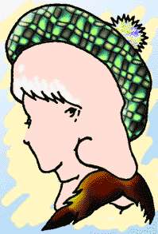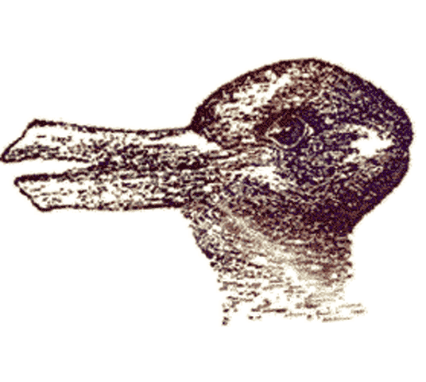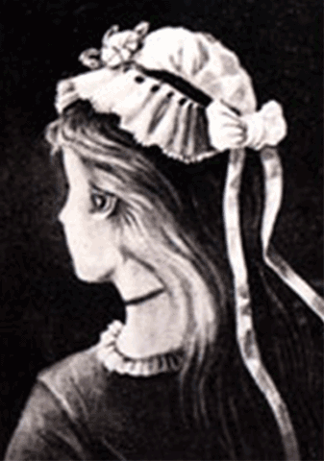

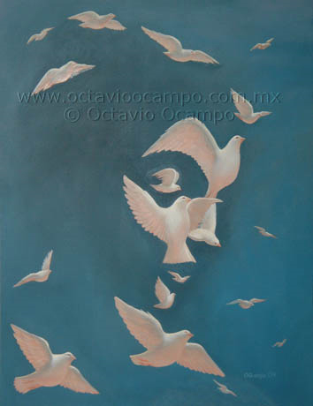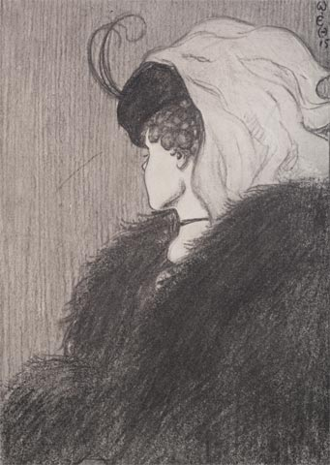

Post Task
At the end of the task, ask pairs to volunteer what they saw in their image.

Make a KWL Chart on the board
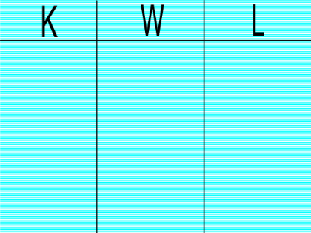
You can use Alutiiq terms: Nallun’itaqa- I know it, Nallun’itayurtua- I want to know it, Litnaullianga- I learned.

Ask students to share what they know about the language used in this activity.
Ask students to share what they want to know, but don’t quite know how to say.
Later, you can revisit this chart and add to it what was learned.

Reflection
I have not implemented this task with my students yet. I am very interested in what language my students would be able to use and what conversations will emerge.
I am interested in using this task with intermediate learners as well. It would be interesting to see what language emerges when more experienced learners converse about these illusions.
One issue that I foresee my students having is talking about what they see. They have body parts vocabulary, but they don’t have a lot of the grammatical knowledge to formulate complete sentences while talking about these illusions.

References

Anderson, N. J. (2008). Metacognition and good language learners. In C. Griffiths (Ed.), Lessons from good language learners (pp. 99-109). Cambridge: Cambridge University Press.

Ellis, R. (2009). Task-based language teaching: Sorting out the misunderstandings. International Journal of Applied Linguistics, 19, 221-246.

