Weather Information Gap Task

Rational

This clothing information gap activity is designed for beginning Alutiiq language learners. It can be used and adapted for any age group of learners. In this activity, students work in pairs to complete two versions of a worksheet with missing information. This activity

This activity supports language learning through these means: requiring students to interact and produce language output and providing opportunities for students to focus on grammatical forms.

Output Hypothesis
Swain (2000) postulates that it is dialogue that constructs linguistic knowledge (p.97). She goes on to describe that the language use is mediating the learning of the L2. Swain (1995) explains that, “output pushes learners to process language more deeply- with more mental effort- than does input,” (2000, p. 99). When producing output, learners can ‘stretch’ their interlanguage to accomplish their communicative goal. When producing output, students are able to notice the difference between what they are able to say and what they want to communicate, they are able to develop and test hypotheses about how the target language works, and they can reflect on the language they have learned.

The clothing information gap task requires students to produce output in the form of questions and responses to questions. Students must communicate information to their partner. While they are communicating, they may notice any difficulties they have communicating, they may generate hypotheses about how the language works and test them with their partner. During the post-task activity, the students will be given the opportunity to reflect on their learning and language use during the task.

Focus on Form
In her Keynote address to the Central Connecticut Teachers of English to Speakers of Other Languages (ConnTESOL) Conference, Nina Spada (2008) differentiated between Isolated and Integrated Focus on Form. She asserts, “Integrated Focus on Form has a primary focus on meaning with attention to form embedded in meaning-based and communicative practices.” According to authors Long and Robinson (1998), “Focus on form refers how focal attentional resources are allocated,” (p. 23). They maintain that during a meaning-focused lesson, teachers often draw attention to linguistic code features, shifting the focus to form.

The clothing information gap task provides an opportunity for students to focus on the singular and dual forms of the Alutiiq language. Students will need to communicate items to their partners; some items will include pictures depicting a single item, while others will contain an image depicting two items.

Description

1) Pre-Task
The teacher will show the students pictures of clothing items and have the students identify them.

The teacher can also ask students to identify their own clothing items and those of their classmates.

2) Task Cycle
Students work in pairs.

A divider, such as two folders, is placed between each student so they cannot see each other’s papers.

In each pair, one student is given worksheet A, while the other student is given worksheet B.

Tell the students that they will need to get the missing information from their sheet from their partner. Each pair has the information that their partner is missing.

The goal of the activity is for each member of the pair to complete their worksheet WITHOUT looking at their partner’s worksheet.

When students have completed their worksheets, they can share their worksheets and compare their information.

Student A

1.  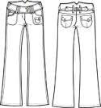 | 2.  ? | 3.  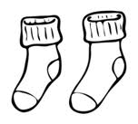
4.  ? | 5.  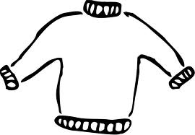 | 6.  ?
7. | 8.  ? | 9.

Student B

1.  ? | 2.  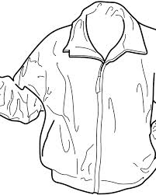 | 3.  ?
4.  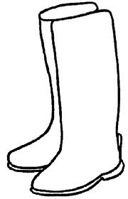 | 5.  ? | 6.
7.  ? | 8.  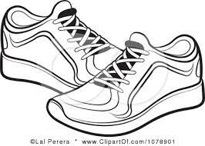 | 9.  ?

3) Post Task
The teacher calls the class back together. She asks the students how they felt about the activity. She can ask questions such as:
- How did you like the task?
- What did you find difficult?
- What did you find easy?
- What types of activities could help you be more successful on this type of task?

Reflection
In the month leading up to this acitivy, we had been practicing our clothing vocabulary. The students had had a lot of practice with their receptive language skills identifying the clothing item after hearing it pronounced in a clothing bingo game. After hearing the item, the students were required to repeat the word before locating it on their bingo boards. The students were able to practice their expressive language skills while playing the game “Guess Who.” The students would ask questions such as, “Is your person wearing glasses?”
During this activity, the students did a good job pronouncing the vocabulary words. It seemed that they were able to distinguish between the singular and dual forms, although they may not be able to discern or pronounce the difference between the singular ending Alutiiq /q/ and the dual ending /k/. During my post-task language focus activity, I could have probed the student’s understanding of grammatical forms by putting the terms from the task on the board asking them questions such as, “What did you notice about the similarities in these words?” and “What do you notice about the differences in these words?” And probe about what they think those differences/similarities mean.

References

Spada, N. (2008). Communicative language teaching: Fact and folklore [PDF document]. Retrieved from ConnTESOL online website: http://www.conntesol.net/documents/Spada%20Keynote%20Presentation.pdf

Swain, M. (2000). The output hypothesis and beyond: Mediating acquisition through collaborative dialogue. In J. P. Lantolf (Ed.), Sociocultural theory and second language learning (pp. 97-114). Oxford: Oxford University Press.

