Caqiq Una? Task

Rational

This task incorporates techniques brought to Kodiak’s community of learners by Evan Gardner, developer of Where Are Your Keys? LLC. The WAYK approach to language teaching and learning integrates Interaction as demonstrated by the motto, “Play a game, learn a language,” (“Where Are Your,” 2011). With the help of the WAYK techniques, the community of Kodiak has experienced an increase in the development of Alutiiq speakers. Over the past couple of years, ten speakers have reached the intermediate or advanced level of language proficiency. It is an interactive, fun way to learn language. I have been able to integrate the WAYK style of teaching into my face-to-face language classes, but have struggled to find a way to integrate it successfully into my distance delivery, VTC classes.

This task was designed for beginner learners for use over distance delivery systems. It integrates resources developed by many Alutiiq language learners. These resources can be found at alutiiqlanguage.org, and vimeo.com/alutiiq. This task was executed over three to four sessions of 45 minutes each session.

This activity supports language learning through these means: allowing the students to focus on form as well as meaning and providing opportunities for interaction.

Focus on Form
In her Keynote address to the Central Connecticut Teachers of English to Speakers of Other Languages (ConnTESOL) Conference, Nina Spada (2008) differentiated between Isolated and Integrated Focus on Form. She asserts, “Integrated Focus on Form has a primary focus on meaning with attention to form embedded in meaning-based and communicative practices.” According to authors Long and Robinson (1998), “Focus on form refers how focal attentional resources are allocated,” (p. 23). They maintain that during a meaning-focused lesson, teachers often draw attention to linguistic code features, shifting the focus to form.

The caqiq una? task allows learners to focus on grammatical forms as they practice communicating meaning. The task cycles extend from the singular, to the dual, to the plural forms: “Caqiq una,” “Caqik ukuk,” and “Caqit ukut?”

Interaction
According to Oxford, in regards to second language learning, interaction is associated with types of learning tasks, the learners’ willingness to communicate, learners’ learning styles, and group processes (1997, p. 449). Oxford also lists task types that promote interaction: simulations, role plays, games, drama, and the use of electronic media.

The caqiq una? task takes the form of a short game. The participants take turns asking and answering questions. New language is introduced in small increments, and the participants take turns passing the new language around until they are ready for the next small piece of language.

Description

1) Pre-Task
You will need two cups and two rocks for this task.
Have the cups and rocks set up on a small table/desk/stool- set the rocks next to each other and the cups next to each other so that if you had four people sitting around your desk/table, each person would have one item in front of them.
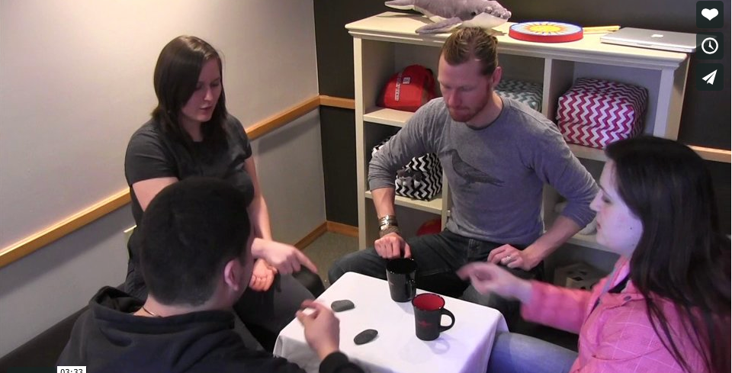

Have the camera of the VTC equipment directed so that the students on the other side can see you and the props set up
Sharing the computer screen over the VTC equipment, show a video of the task to the students, to let them preview how the task will go: http://vimeo.com/63357975

This task incorporates techniques introduced by Where Are Your Keys?, LLC. These techniques are explained at http://www.whereareyourkeys.org/techniques.html#start.

The teacher introduces/reviews the vocabulary to be used in this task:
- Demonstrate the ASL sign for “What is this?”- hand signs are demonstrated on the video
- Have students copy-cat your motions
- Doing the hand-sign for “What is this?” introduce the Alutiiq “Caqiq una?” and point to the rock, having the students copy-cat you three times
- Then ask the students in the other site(s) ask you that question (have them point to the rock on their side of the camera). Tell them, “Now all of you ask me, “Caqiq una?”
- Answer their question, “Una yaamaq.” Have them ask you two more times, each time answering their question.
- Tell the students, “Now I am going to ask you. Caqiq una?”- point at the rock on your side. Have the students answer you with “una yaamaq.” If they have trouble answering correctly, you can model the question and answer turn taking that you are looking for with someone on your side, or you can model this with the teacher on the other side of the camera.
- Ask them “Caqiq una?” while pointing at the rock two more times (a total of three times). Have the students answer you.
- Tell the students, “Now you are going to ask me ‘Caqiq una?’” – and point to one of the cups.
- Answer the students with “Una caskaq.” Have them ask you two more times. Answer them with the same “Una caskaq.”
- Tell them, “Now I am going to ask you, ‘Caqiq una?’”- point to a cup. Have the students answer you.
- Ask the students if they are ready to play the game. If they are ready, move on to the task. If they are not ready, continue asking the students “Caqiq una?” pointing at both the rock and the cups, then have the students practice asking, “Caqiq una?” while you answer-until they are ready to move on.

2) Task Cycle
Explain that we are going to play a game. “Wamkutartukut!”

Make sure that they have their table set up as the above picture, with four participants, each with one item in front of them.
- If there are enough students for multiple table groups, they can set up multiple tables, each group needs two cups and two rocks.
  - Otherwise, extra students can sit circling the four participants, learning along with the “inner-circle” of four participants.
  - Once the inner-circle members are comfortable with the language, they can hop out and one of the circling students can jump in and fill their seat.
Ask the students who feels comfortable with the question and answers. Choose one student who self-identifies.

Explain to that student that they will be asking the student on their right, “Caqiq una?”- starting with the item in front of them [the questioner]- circling around the table to the right [counter clockwise] pointing at each of the items until they come back around to the one in front of them.

Then they will hand it off to the student on their right- who was answering- it is now their turn to ask the question of the student on their right- circling around the table, pointing to each item, beginning with the item in front of the questioner.

They will continue around the circle until each participant has had an opportunity to ask and answer the question, “Caqiq una?” for all of the items on the table.

As they are rotating, you are monitoring their playing, making yourself available for answering questions or making any corrections necessary.

When the class comes back to you, ask them if they are feeling comfortable with this language and are ready for the next little bit of language. If they indicate they are ready, you can move on to the next bit.

You can use the videos from Vimeo.com to help, either showing them to the students as another preview or by watching them yourself so you are familiar with each step of the task.
- “Caqiq una?- Aa’a” http://vimeo.com/63438543
- “Caqiq una?- Qang’a” http://vimeo.com/63442709
- The script and video links are also available from www.alutiiqlanguage.org
  - http://www.alutiiqlanguage.org/html/start-learning/caqiq-una.php

- Introduce the terms “Aa’a”- yes and “Qang’a”- no by demonstrating the ASL hand signs that go with them. Have the students copy-cat the motion and words three times.
- Have the students copy-cat as you introduce a new question- “Una yaamaq-qaa?”- point to the rock as you ask. Have the students copy-cat three times.
- Tell the students to ask you “Una yaamaq-qaa?”- while pointing at the rock
- Answer them with “Aa’a, una yaamaq.”- Have them ask you three times.
- Tell the students that you will now ask them. Ask them “Una yaamaq-qaa?”- point to the rock. Ask and have them answer you three times.
- Then start at the beginning- ask the student “Caqiq una?” while pointing to the rock. Once the students answer with “Una yaamaq.” Ask them, “Una yaamaq-qaa?” Have them answer you. Practice three times.
- Move on to the cup. Ask the students, “Caqiq una?” Have them answer, then ask, “Una caskaq-qaa?” Have them answer you. Repeat three times.
- Ask the students if they are comfortable with the language and are ready to practice this in their table game. If so, have them go back to their game, following the same format as before, just adding in the additional question and answer.

Again, monitor students as they play. Make yourself available for questions and for any corrections that are necessary.

When the class comes back to you, ask them if they are feeling comfortable with this language and are ready for the next little bit of language. If they indicate they are ready, you can move on to the next bit.

- Review the terms “Aa’a”- yes and “Qang’a”- no by demonstrating the ASL hand signs that go with them. Have the students copy-cat the motion and words three times.
- Have the students copy-cat as you introduce a new question- “Una caskaq-qaa?”- point to the rock as you ask. Have the students copy-cat three times.
- Tell the students to ask you “Una caskaq-qaa?”- while pointing at the rock
- Answer them with “Qang’a, caskaunituq. Una yaamaq.”- Have them ask you three times.
- Tell the students that you will now ask them. Ask them “Una caskaq-qaa?”- point to the rock. Ask and have them answer you three times. You may need to break the term “caskaunituq” into smaller chuncks for the students.
- Then start at the beginning- ask the student “Caqiq una?” while pointing to the rock. Once the students answer with “Una yaamaq.” Ask them, “Una yaamaq-qaa?” Have them answer you, “Aa’a, una yaamaq.” Ask them, “Una caskaq-qaa?” have them answer you, “Qang’a, caskaunituq. Una yaamaq.” Practice three times.
- Move on to the cup. Have the students ask you from the beginning, “Caqiq una?” Answer them, “Una caskqa.” Have them ask you, “Una caskaq-qaa?” Answer them, “Aa’a, una caskaq.” Then have them ask you, “Una yaamaq-qaa?” Answer them “Qang’a, yaamaunituq! Una caskaq.”
- You ask them from the beginning. Have them practice three times.
- Ask the students if they are comfortable with the language and are ready to practice this in their table game. If so, have them go back to their game, following the same format as before, just adding in the additional question and answer.

Again, monitor students as they play. Make yourself available for questions and for any corrections that are necessary.

Post Task
The teacher does a “Plus/Delta” with the students.
The teacher lets the students know that we will talk about what they liked about the acitivity, and what they would change if they could.
Begin with Pluses. Ask the students to share something they liked about the activity. Allow students to share until they have run out of things that they like about the activity.
Now let the students know that we will go over Deltas. Tell them that if they had a million dollars, or a magic wand, what would they change about the activity.
Allow the students to share until they have run out of things they would change.

Extensions
This task can be used with a single distance class over VTC, or with multiple classes connected at the same time. When working with multiple classes, the teacher takes turns interacting with each class that is connected. Each class has an opportunity to respond to questions and to ask questions.

- Once classes have completed this task, the next step is to move to the dual form “Caqik ukuk?” now table groups use four rocks and four cups. They follow the same progression, but using the dual form, pointing to two items at a time.
- The next step is to move into the plural form “Caqit ukut?” now table groups use 6+ rocks and 6+ cups. They follow the same progression, but using the plural form, pointing to 3+ items at a time.

Reflection
I attempted a less-interactive version of this task at the beginning of this school year. I used a Power Point presentation that I shared over the VTC. The students saw pictures of rocks and cups. I asked them the question, “Caqiq una?” and the students answered me, “Una yaamaq,” or “Una caskaq.” In January, I held up a rock to the students and asked them, “Caqiq una?” None of the students in that particular class could answer the question. They had not retained the language from my Power Point lesson.
I knew that I needed to make this activity more interactive. We have proven that integrating the table game has aided in learning and retention of the language. I needed to find a way to take what we have been doing in the face-to-face lessons and successfully implement it in a distance-delivery setting.
I used this task with all three of my distance elementary classes. On Wednesdays, I work with two elementary classes at the same time. One class, in Ouzinkie, has intermediate elementary students from grades three through five. The other class, in Akhiok, has students from Kindergarten to grade five. The Akhiok class paired their younger students up with an older language buddy. They had one table group of eight students as each student was paired up. The Ouzinkie class had two table groups running at the same time. On Thursdays, I work with one class in Chiniak. This class has young students ranging from Kindergarten to second grade.
This more interactive task was much more successful. The students were willing to communicate with each other. When the classes had questions, they would ask me. As I was watching the Akhiok students playing the first round of this task, I noticed that the students were not quite following the turn-taking procedure of this task. I was able to demonstrate how the turns were to be taken, modeling with a student from Old Harbor.
By having the students practice in groups at their site, the students were given much more opportunities to ask and answer the questions as compared with the four times they were afforded with the Power Point activity.
I did the Plus/Delta activity with the students. One thing that stood out in the Deltas is that one student said that he wished it was more challenging.

References

Oxford, R. L. (1997). Cooperative learning, collaborative learning, and interaction: Three communicative strands in the classroom. The Modern Language Journal, 81, 443-456.

Spada, N. (2008). Communicative language teaching: Fact and folklore [PDF document]. Retrieved from ConnTESOL online website: http://www.conntesol.net/documents/Spada%20Keynote%20Presentation.pdf

