Weather Information Gap Task II

Rational

This weather information gap activity is designed for beginning Alutiiq language learners. It can be used and adapted for any age group of learners. In this activity, students work in pairs to complete two versions of a worksheet with missing information. The weather clip art images were found at Best Clip Art Blog, Clip Art Pin.com, and 4vector.com.

This activity supports language learning through requiring students to interact and produce language output and enabling students to focusing on form as well as meaning.

Output Hypothesis
Swain (2000) postulates that it is dialogue that constructs linguistic knowledge (p.97). She goes on to describe that the language use is mediating the learning of the L2. Swain (1995) explains that, “output pushes learners to process language more deeply- with more mental effort- than does input,” (2000, p. 99). When producing output, learners can ‘stretch’ their interlanguage to accomplish their communicative goal. When producing output, students are able to notice the difference between what they are able to say and what they want to communicate, they are able to develop and test hypotheses about how the target language works, and they can reflect on the language they have learned.

This weather information gap activity requires learners to solicit information from, as well as, communicate information to their partner. Students must interpret the input (questions) posed by their partner and generate the appropriate answer. Students will have the opportunity to notice the gaps in their abilities, test out their hypotheses, and to reflect on their learning.

Focus on Form
In her Keynote address to the Central Connecticut Teachers of English to Speakers of Other Languages (ConnTESOL) Conference, Nina Spada (2008) differentiated between Isolated and Integrated Focus on Form. She asserts, “Integrated Focus on Form has a primary focus on meaning with attention to form embedded in meaning-based and communicative practices.” According to authors Long and Robinson (1998), “Focus on form refers how focal attentional resources are allocated,” (p. 23). They maintain that during a meaning-focused lesson, teachers often draw attention to linguistic code features, shifting the focus to form.

The primary focus of this weather information gap activity is on meaning- soliciting information from, and communicating information to, your partner. During the pre-task portion of this activity, the teacher can draw the students’ attention to certain code features such as the locative case –mi.

Description

1) Pre-Task
The teacher projects a picture of Kodiak Island, which includes the Alutiiq place names for the villages. The teacher asks the students questions about the picture to activate their background knowledge. The teacher can ask questions such as:
- What do you notice?
- What can you tell me about this picture?
- Where is this?
Depending on how much the students know, the teacher can introduce/review the place names with the students, either reading them to the students or having students volunteer to read/say the place names for the given locations.
The teacher will then ask the students guiding questions such as:
- How do you say in ________?
- How do you ask about the weather in _______?

The teacher will then have the students take turns using the –mi locative case to say, “in _____.”

2) Task Cycle
Students work in pairs.

A divider, such as two folders, is placed between each student so they cannot see each other’s papers.

In each pair, one student is given map A, while the other student is given map B.

Tell the students that they will need to get the missing information on their sheet from their partner. Each pair has the information that their partner is missing.

The goal of the activity is for each member of the pair to complete their map WITHOUT looking at their partner’s map.

When students have completed their map, they can share their maps and compare their information.

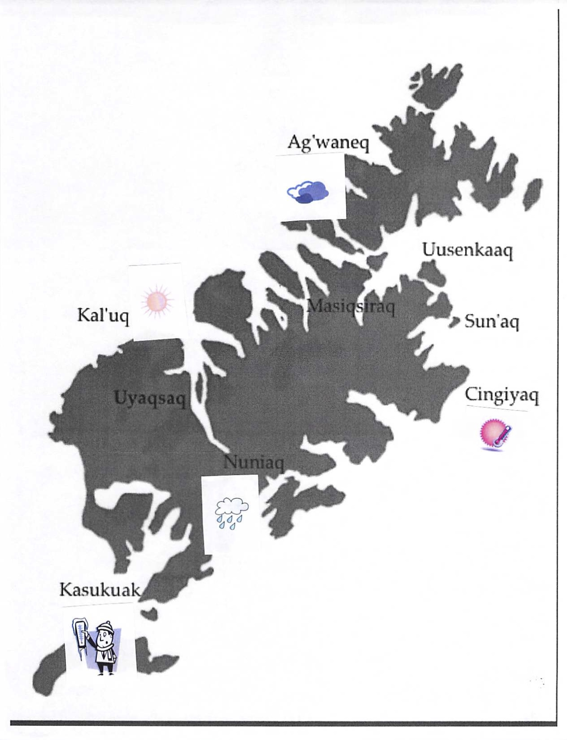
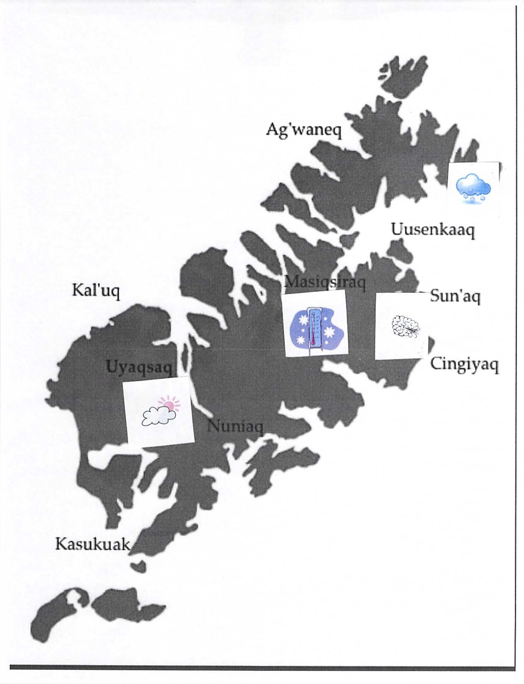

3) Post Task
The teacher calls the class back together. She asks the students how they felt about the activity. She can ask questions such as:
- How did you like the task?
- What did you find difficult?
- What did you find easy?
- What types of activities helped you to be successful on this type of task?
- What types of activities could help you be more successful on this type of task?

Reflection
This weather activity was a follow-up to the weather information gap activity. Following the first activity, the students wanted to practice their weather vocabulary by using games such as bingo. I developed two weather bingo games; one that required students to find the picture depicting the weather word that I said for them, and one that required them to find the written weather word when I showed them the image depicting the weather. We played these weather bingo games for a week.
After one week, I gave the students the weather information gap 2 activity. Most students felt more confident with the weather vocabulary. Most of the learners were able to ask the question, “Cestun lla et’a __________-mi?” They did not have too much difficulty pronouncing the place names, which we had reviewed during the pre-task portion.
When asked how they felt about this activity, the majority of the students said they enjoyed it (four out of six thumbs up). One student said it was easier than the first weather information gap activity because they had practiced weather words by playing bingo. The students reported that some of the village words were hard to pronounce, but the words were written for them on the page and they could read them. Other comments made by the students were that this activity was “simple” and “fun.”

References

Spada, N. (2008). Communicative language teaching: Fact and folklore [PDF document]. Retrieved from ConnTESOL online website: http://www.conntesol.net/documents/Spada%20Keynote%20Presentation.pdf

Swain, M. (2000). The output hypothesis and beyond: Mediating acquisition through collaborative dialogue. In J. P. Lantolf (Ed.), Sociocultural theory and second language learning (pp. 97-114). Oxford: Oxford University Press.

